**Bootcamp NAO x TecMilenio**

**Campus Monterrey**

**GROUP 1**

**Technical Report. Non-Relational Databases for Storing JSON Data**

**Sofía Pérez Guzmán**

**NAO ID: 3350**

**10/08/25**



**Table of Contents**

Executive Summary 3

## **Executive Summary**

Business overview: Tattler is a modern web application designed to be a nationwide restaurant directory in Mexico.

This report explains to you how to provide up-to-date information, personal recommendations, and allow users to interact by adding comments, ratings, and new restaurants. In this repository contains the initial database setup, data import scripts, and documentation for the Tattler application backend.

This project aims to address the recent drop in user traffic by significantly improving the user experience and ensuring the directory's content remains current and relevant.

## Installation and Usage

**Major Version: 1.0.0**

**Prerequisites**

* Node.js (v18.x or later recommended)
* npm (v9.x or later recommended)
* MongoDB (v6.x or later recommended, either local or via Atlas)
* Git

**Installation**

1. **Clone the repository in Git Bash:**

git clone <git@github.com:SofGuzman-Mx/Non-Relational-Databases-for-Storing-JSON-Data.git> cd tattler-db

1. **Install dependencies**

The import scripts require the mongodb and csv-parser packages.

npm install mongodb csv-parser

1. **Configure Environment:** Ensure your MongoDB server is running. Create a .env file in the root directory and add your MongoDB connection string:

MONGO_URI="mongodb://localhost:27017/tattler_db"

1. **Database Setup & Data Import**

You can populate the database in two ways:

*# Import restaurants*

*node scripts/import-restaurants.js*

*# Import users*

*node scripts/import-users.js*

B) Restoring from Backup:

Use the mongorestore command-line tool to restore the database from the provided backup files located in the db_backup/ directory.

*mongorestore --uri="mongodb://localhost:27017" --db tattler_db db_backup/tattler_db*

**Sprint 1: Begin the configuration and development of the database in MongoDB**

Collection restaurants around Mexico

Collection users around Mexico

Sprint 2: Develop a RESTful API using Express.js and MongoDB:

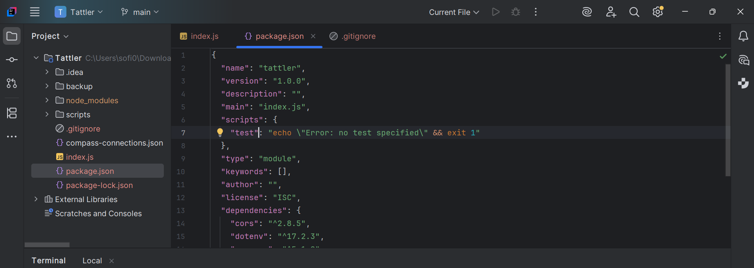

Se genera el .env en nuestra carpeta raiz

Si imprimió 3000, si corre bien

Se crea una carpeta db> file (connectin.js)

NOTAS: ¿Qué es MongoDB?

SGBD (Sistema Gestor de Base de datos) NoSQL

Cada registro se almacena en un documento **JSON**

* Los documentos están compuestos por campos
* Se agrupan en colecciones

Instalando Drivers permiten utilizar otros lenguajes: Java,PHP, C#, Python, Ruby, etc

¿Por qué usarlo?

* Modelado flexible de datos
* Alto rendimiento de escritura y consultas
* Alta escalabilidad
* Dispone de un servicio de gestión de cluster de BD
* Por que es el SGBD más popular de los tipo NoSQL

Fuente: [www.db-engines.com](http://www.db-engines.com)

SetUp

Install Compaas herramienta que permitirá visualizar y editar gráficos en MongoDB

Atlas Servicio de cluster de datos

***Tipos de datos:***

-Cadenas de caracteres (string)

-Enteros (int32),

-Decimales (double)

-Fechas (date)

-Documentos (Object-Document)

-Vectores (Array)

Subir todo de esa carpeta, te situas en la carpeta que quieres

git status

git add .

git commit -m “NOMBRE acorde al cambio”

git push

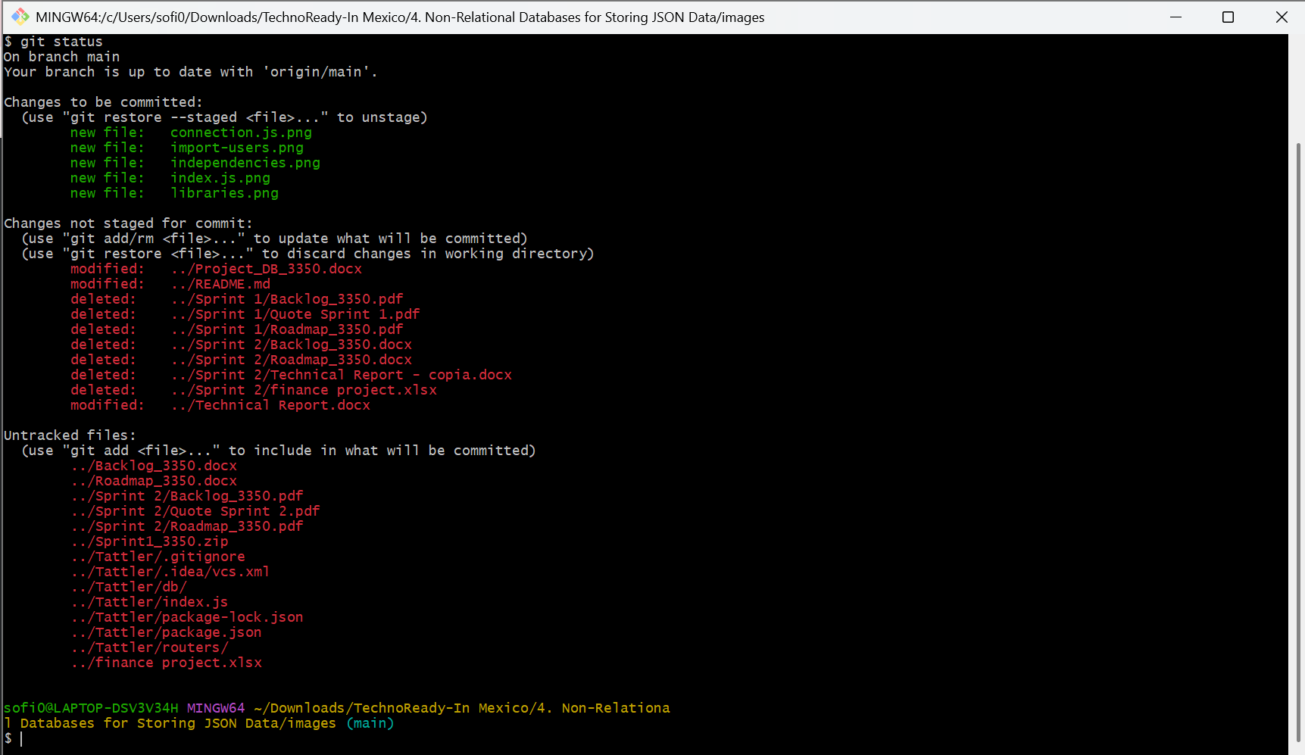

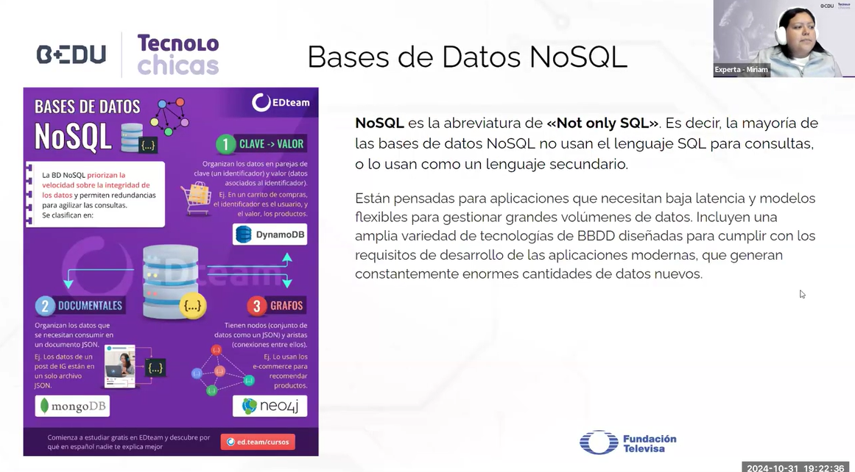**FUNDAMENTOS DE MONGODB**

Esta especie de datos se utilizan en **IA**

**Características y ventajas**

* Estructuras de datos flexibles, en lugar d elas relaciones tabulares estándar
* Baja latencia
* Escalabilidad horizontal
* Gran número de usuarios simultáneos
* Optimizado para grandes volúmenes de datos -ya sean estructurados, semiestructurados o sin estructurar
* Arquitectura distribuida que permite gestionar grandes cantidades de datos
* Adaptadas a sprints de desarrollo ágil
* A blue sign with white text

  AI-generated content may be incorrect.Mayor rendimiento, velocidad y escalabilidad